Zomato Clone

Backend APIs for User registration, restaurant registration, location based recommendations, categories, search filtration, post delivery data, etc.

# Objective

Create the application of zomato which is famous for delivering food to their customers.

|  |  |  |  |  |
| --- | --- | --- | --- | --- |
| No | Name | Description | Date | Version |
| 1 | Hrishikesh | Created zomato Documentatio file | 21-03-22 | 0.1 |
| 2 | Hrishikesh | Created ER Diagram | 22-03-22 | 0.2 |

# Features

|  |  |  |
| --- | --- | --- |
| Title | Description | Comments |
| User | * If their is new user then sign up * If it is registered user then login |  |
| Add new restaurant | * Create new restaurant * If it already exists just login. |  |
| Location | * Discover the bestest and nearest restaurant by using user location. * Classify food into food types like (delivery, dining out, nightlife). |  |
| Types of food Categories | * veg, non veg, continental * Menu Card Showing Items by sorting of Price. |  |
| Type of menu | * sweets, sandwiches, Pizza, chaat, Burger, Fries, Ratings. |  |
| Options | * Popularity (High, Low) * Cuisines(eg, American, Chinese etc) * Rating (0-5) |  |
| Filter | * List of Images of selected food, * Restaurants name, * Location, * Shop Timing, * Bookmark and * Share button, * Reviews(0-5) * Price |  |
| Detail After selection of Item | * Photos * Overview (Rest Popular dishes, More Info, Sponsors) * Order Online also shows recommended dishes. * Detailed review * Menu (Menu Images) |  |
| Detailed description of Item | * Name of food, * Location of Restaurant, * Reviews, * Price |  |
| After Ordered food it must display | * Order Total * Delivery time. |  |

# ERD Diagram

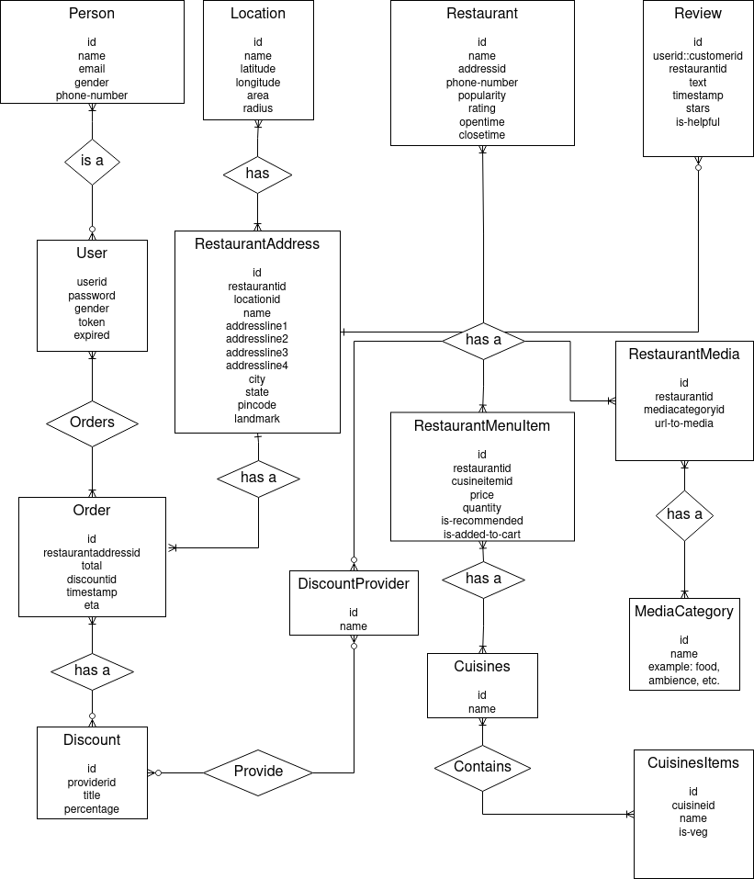

# Tech Stack

* IDE: Intellij IDEA
* Programming Language: Java
* Framework: Spring Boot
* Database: PostgreSQL